

**COEN 6312**

**Model Driven Software Engineering**

**Deliverable-2**

**Project-Team**

|  |  |
| --- | --- |
| Name | ID No. |
| **Ganesh Santhar** | **40010625** |
| BhanuPrakash Ramineni | 27107838 |
| Jithin James | 27420854 |
| Rambabu Kunchala | 27262957 |
| Rakhi Ubriani | 27396333 |
|  |  |

**Index**

1. Introduction 2

1.1 Purpose 2

1.2 Scope 2

1.3 General Description 2

2. User Requirements 2

2.1 Use Case Descriptions 3

2.2 Use Case Scheme 4

2.3 Complete Description of Use Cases 5

3. System Requirements 12

3.1 Functional Requirements 12

3.2 Non-Functional Requirements 13

Glossary 14

References 14

Appendix 14

# Introduction

## General Description

The Flight Reservation System enables a Traveler to book flights online. It provides a sophisticated interface for the User to do the same. The system offers to create a personal account and can login into it. A Traveler will be able to search Flights based on various criteria namely Domestic or International travel, One way or Round Trip, Source, Destination, Date of travel, Number and Type of passengers. Upon Flight selection it allows the Traveler to book the flight with facility to make online payment. The Traveler will have two modes of online payment through Credit/Debit card, Interac transfer and through Points payment. The system completes the Bank involved payments with a validation from the networked Bank systems. Once the booking is successful, the Traveler can Cancel the booking and can Modify to the booking like changing seats and adding extra baggage. An Administrator who looks after the system can be able to update the Flight database.

# User Requirements

This section will analyze the system considering to various User Interactions. The system comprises of 3 actors interacting with the system. The following information will provide the Use Case descriptions and the Scheme demonstrates the Users Interaction with the system.

## Use Case Descriptions

|  |  |  |
| --- | --- | --- |
| **S. No** | **Use Case name** | **General Description** |
| 1. | Update Flight DB | The Administrator update the flights information in the database. |
| 2. | Create Account | The Traveler can create a personal account in the system. |
| 3. | Login | The User can login into personal account with valid account credentials. |
| 4. | Search Flights | The Traveler can search for the flights based on search criteria. |
| 5. | Flight Booking | The Traveler can book a flight from the retrieved search results. |
| 6. | Make Payment | The Traveler needs to make payment for the booking in process. |
| 7. | Cancel Booking | The Traveler can cancel the booking with the respective booking reference ID. |
| 8. | Modify Booking | The Traveler can make modifications to the booking. |
| 9. | Earn Points | The Traveler with personal account will earn points for the miles travelled with the previous bookings. |
| 10. | Payment via points | The Traveler can redeem their points as a payment for the current booking. |
| 11. | Payment via Credit/Debit card /Interac transfer | The Traveler can make payment for the booking with a Credit/ Debit card/ Interac transfer. |
| 12. | Validate Payment | The Bank will validate the Credit /Debit card /Interac transfer details of the booking payment. |

## Use Case Scheme

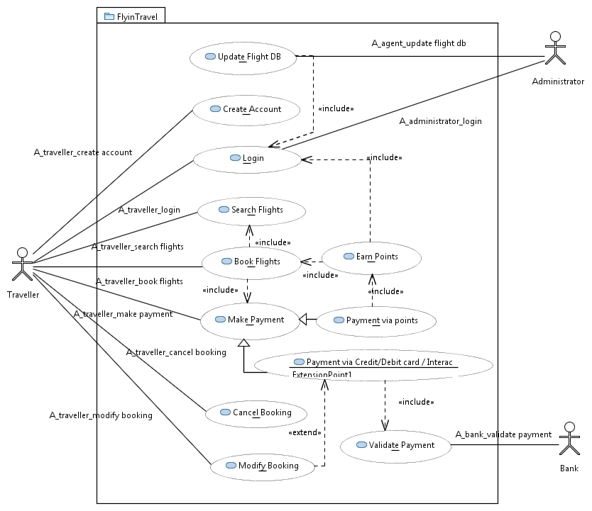

# References

1. Papyrus Use case- <https://wiki.eclipse.org/Papyrus_for_Education#Use_Case_Diagram>
2. IEEE format-<http://ieeexplore.ieee.org/xpl/articleDetails.jsp?arnumber=502838&filter=AND(p_Publication_Number:3731)>

# Appendix

1. Use Case Diagram UML file

[usecasediagram_new.rar](https://github.com/bhanu550/FlyinTravel/tree/gh-pages/D2_Domain_Analysis_and_Requirements/usecasediagram_new)